**Do I need to uninstall the previous ASUS MB series driver before trying the new DisplayLink Manager App?**

Yes. The best way to try the new DisplayLink Manager app is to first uninstall previous driver and then install the latest DisplayLink Manager app.

**How to use the new DisplayLink macOS App?**

We recommend proceeding with following steps to install and use the new DisplayLink macOS App. They are to be followed once after installing the app.  
1. First, uninstall the classic DisplayLink driver if you have it on your computer. Simply run the driver installer and select Uninstall.   
2. Download the DisplayLink macOS app and install it from the ZIP file  
3. Navigate in Finder to Applications and then open DisplayLink Manager

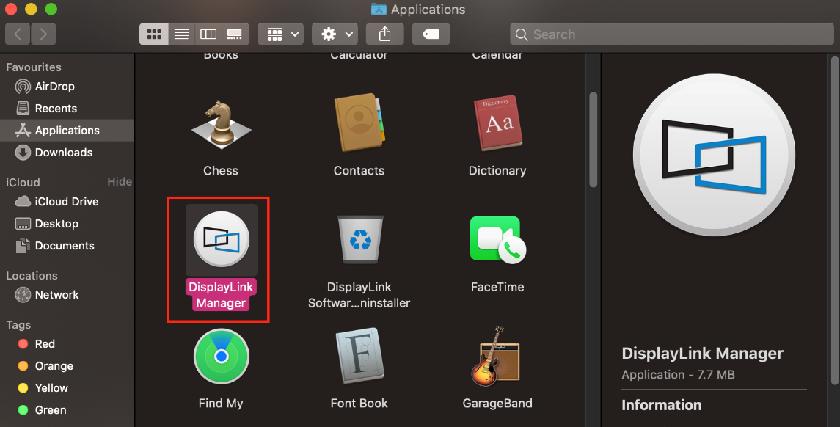

4. Click on the DisplayLink Manager app icon from the notification area to open the app window. This confirms the software is installed and running properly

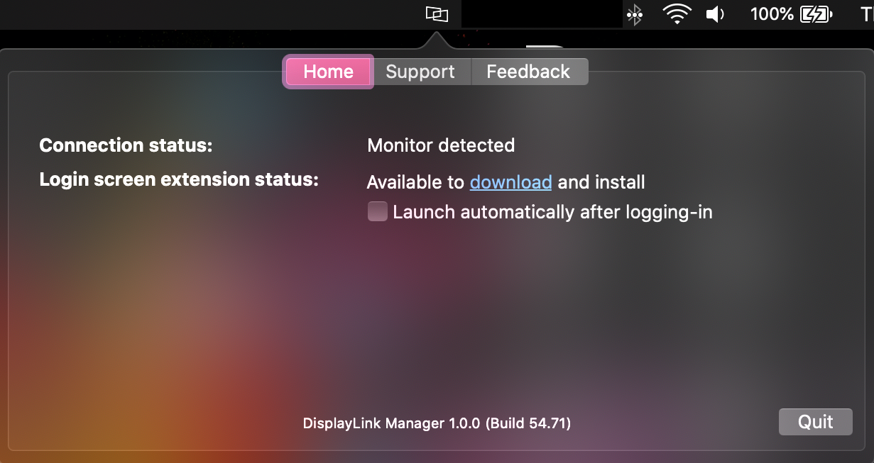

5. Select “Launch automatically after logging-in” for the software to start automatically every time you log-in.

Note: this is not compulsory but recommended to save you from repeating step 5.3 each time you login.

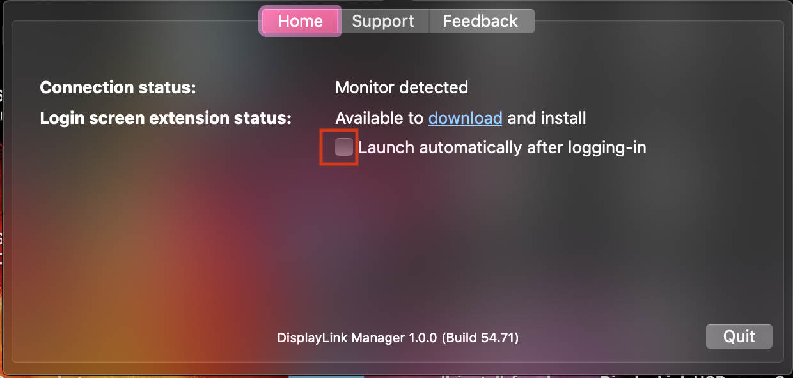  
6. **Now connect the ASUS portable monitor to your Mac system**, and navigate to your System Preferences to open Security & Privacy

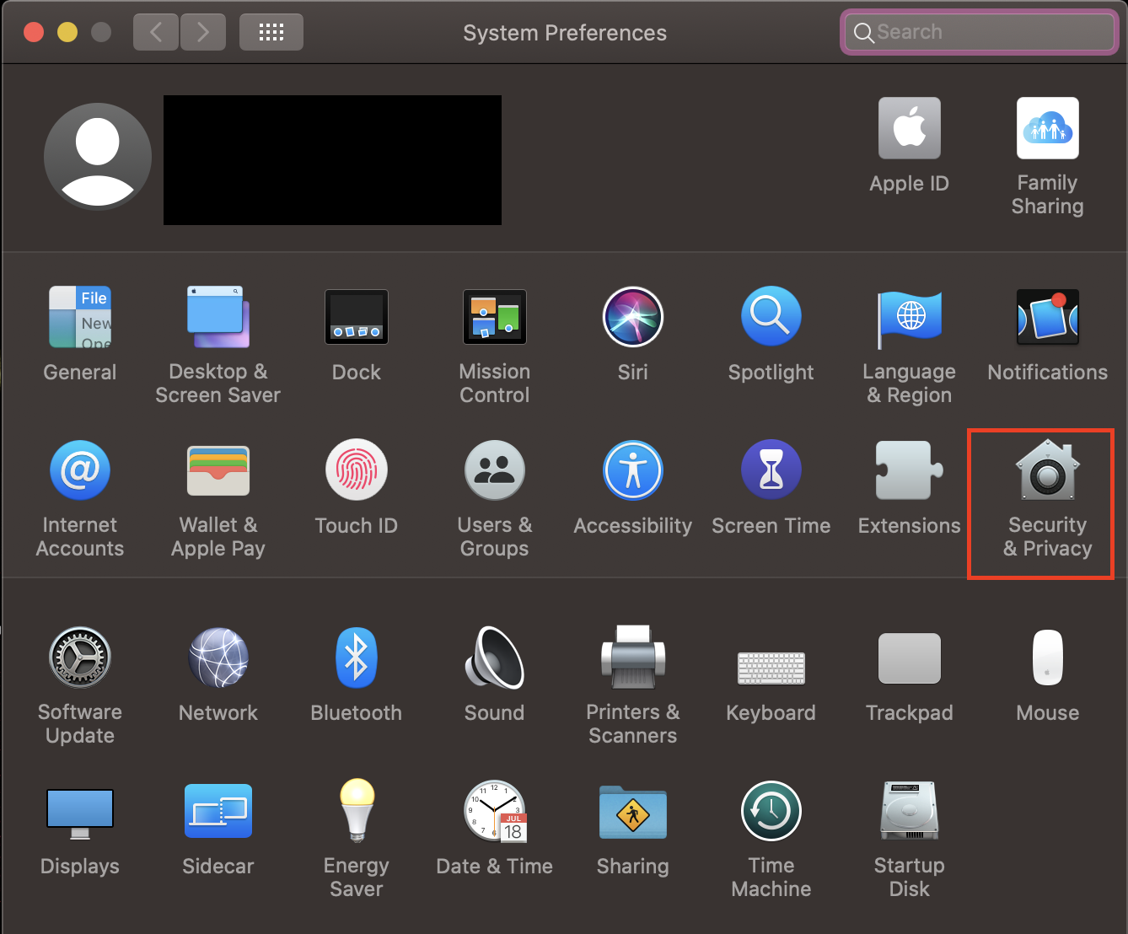

7. Enable “Screen Recording” to allow the DisplayLink Manager app to capture pixels and send them to your USB peripheral:

* Select the “Privacy” tab
* Navigate to “Screen Recording” in the list on the left
* Then tick the “Screen Recording” permission for DisplayLink Manager.

NOTE: macOS Catalina 10.15 requires the user to permit "Screen Recording" in order for DisplayLink devices to work properly. The message is generated by the OS and the screen is not actually being recorded by DisplayLink. Approving it enables the DisplayLink driver to access the pixels it needs to render a mirrored or extended screen and send the pixels over USB from your computer to the DisplayLink display. DisplayLink Manager does not store or record any screen content.  
  
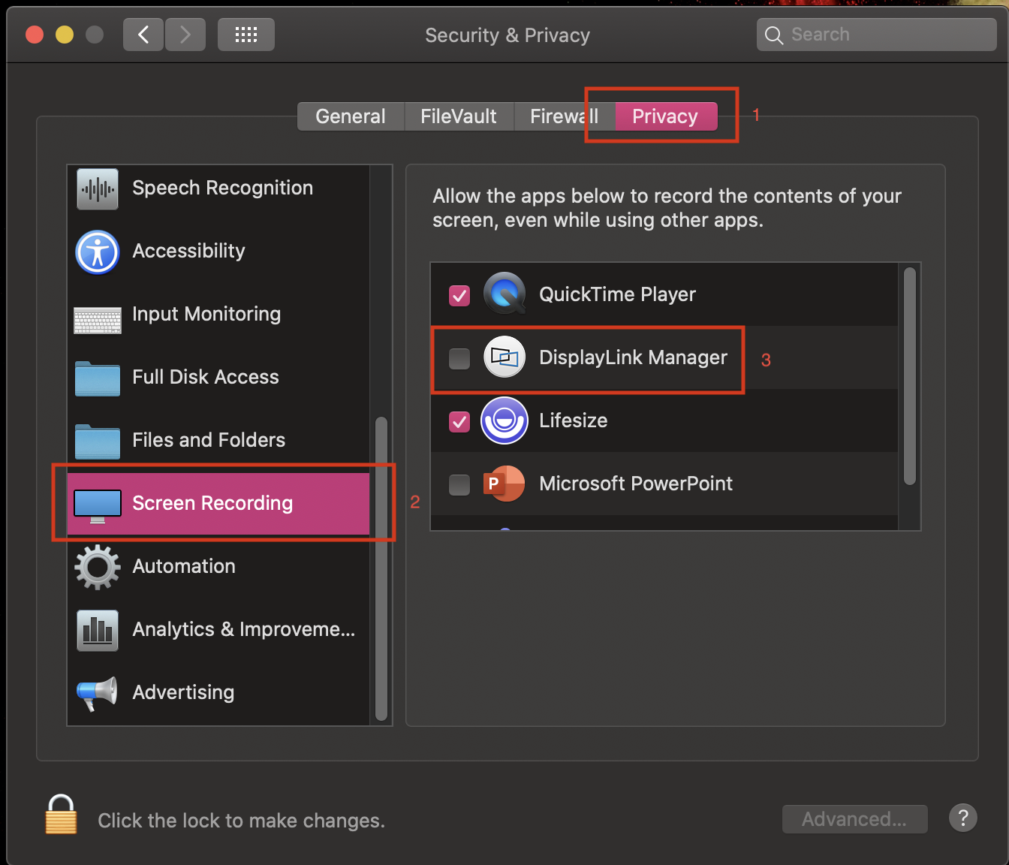

Because the new permission will only be active the next time you start the application, macOS will invite you to “Quit Now”. Please accept.   
  
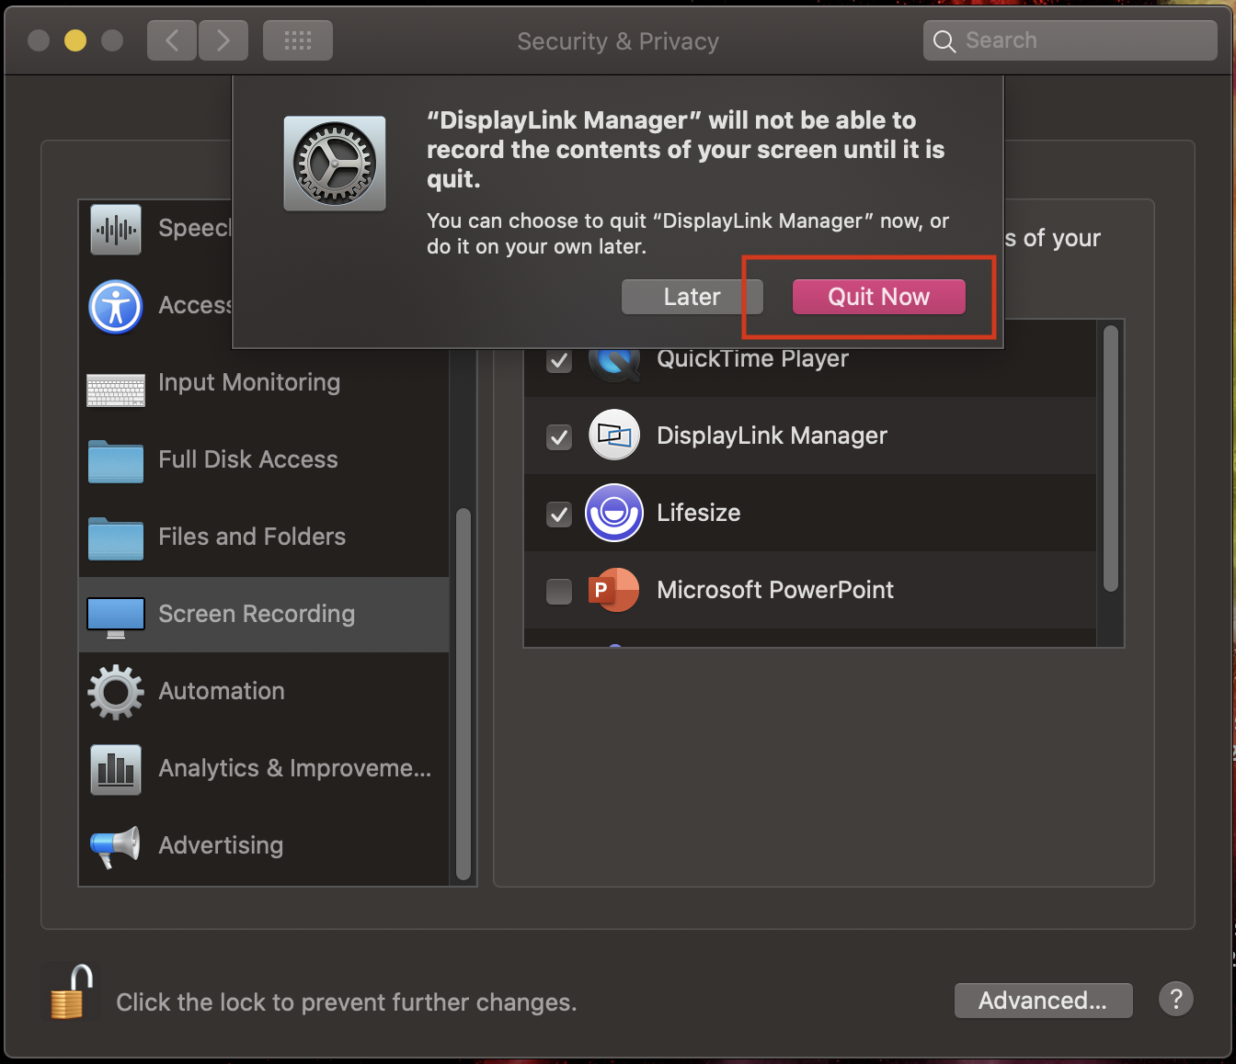  
Now it has adequate permissions, re-open DisplayLink Manager from Applications in the Finder.  
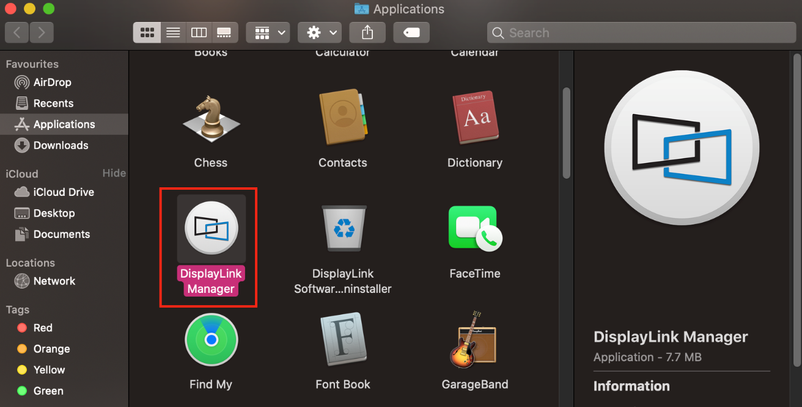  
  
Your displays are now working properly.

If you enabled notifications from DisplayLink Manager, it will remind you to allow Screen Recording if it detects this permission is missing.

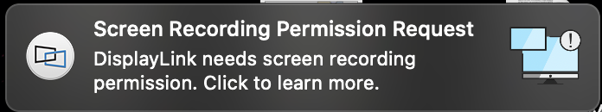

Other functions of the DisplayLink Manager

Login screen extension

Login screen extension enables the external screens to be available on login screen prior to the app loading after logging into your account.

1. To use the Login screen extension please download it from the link available on the front page of the DisplayLink Manager.

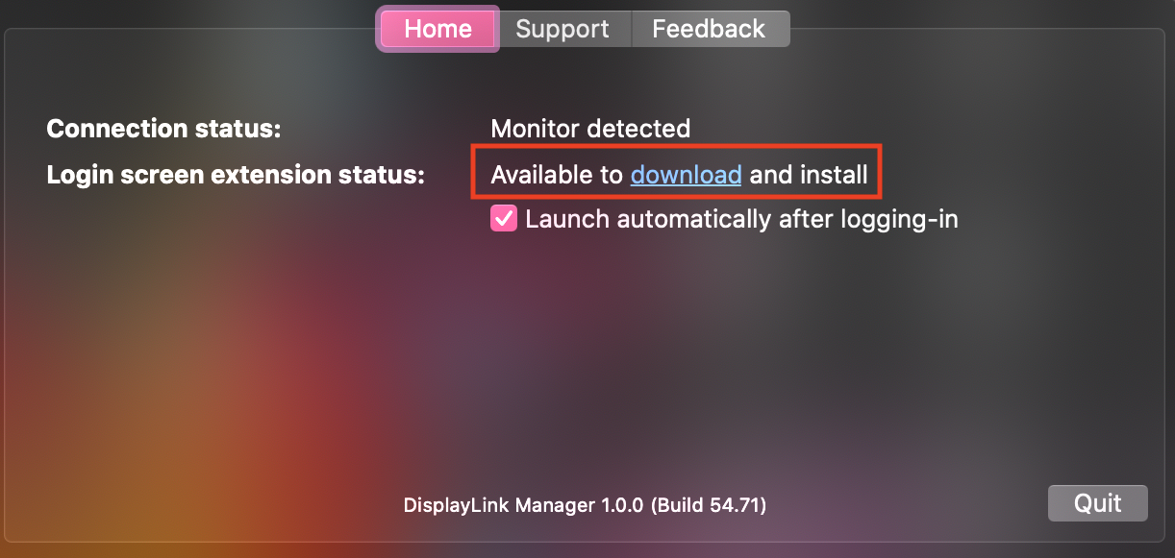

2. Install the extension

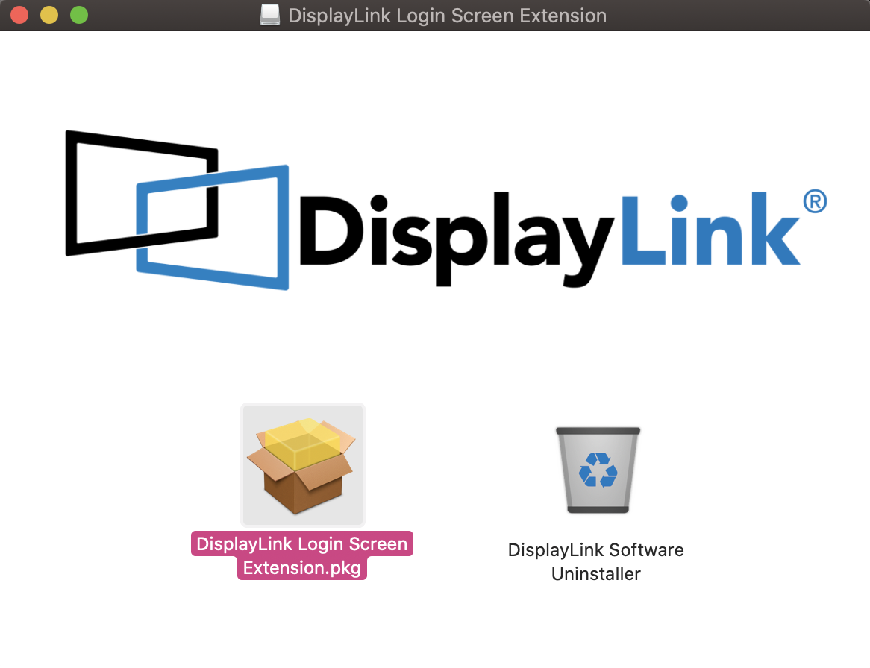

3. Once the installation is complete the extension will show as ‘Installed’ in the DisplayLink Manager.

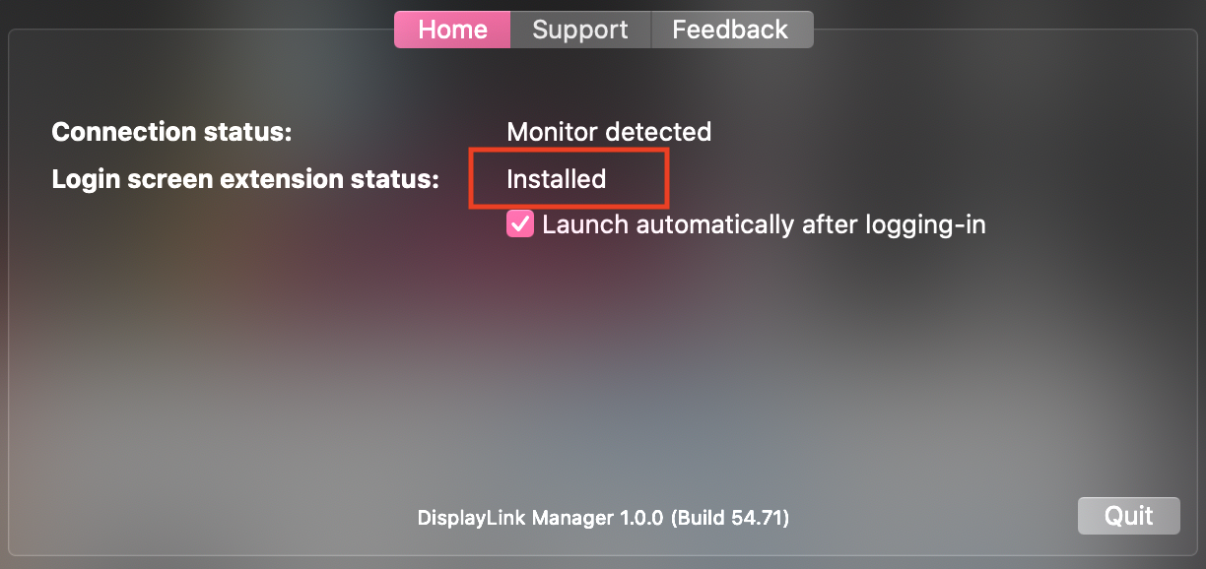

**How to uninstall the app?**

1. Locate the app in the Finder, or navigate in Finder to Applications and then press the app” DisplayLink”
2. Drag the app to the Trash, or select the app and choose File > Move to Trash.